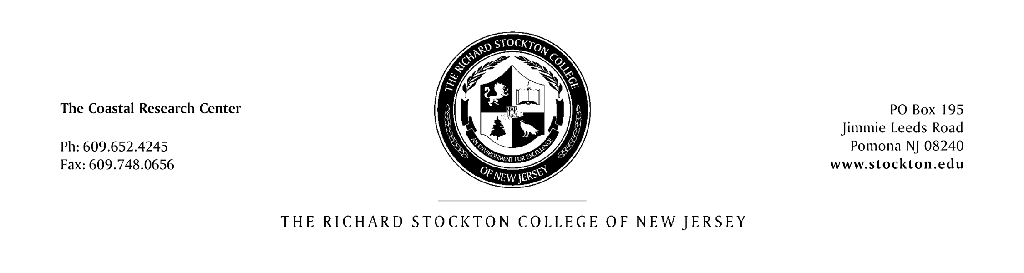

Genevieve Boehm-Clifton May 28, 2008
New Jersey Department of Transportation
Office of Maritime Resources
1035 Parkway Avenue
3rd Floor Main Office Bldg
PO Box 837
Trenton, NJ 08625

Dear Ms. Boehm-Clifton,

Enclosed with this letter is the Atlantic County electronic report for the Sediment Characterization and Management of New Jersey’s Coastal Waterways project supported by the IBOAT NJ program.

The electronic report found on the associated DVD-ROM, functions similar to a standard webpage, where there are links to various resources and data found within the disc. The report was constructed in this manner to optimize and organize the immense amount of data collected and compiled within Atlantic County, New Jersey’s coastal zone.

We have now started writing the Cape May County electronic report, which will be the next deliverable for this project.

The project team would like to thank you for your continued support and hope you will be pleased with the product generated for Atlantic County. We are confident that this information will no doubt aid in current and future dredged material management in the state of New Jersey.

Sincerely,

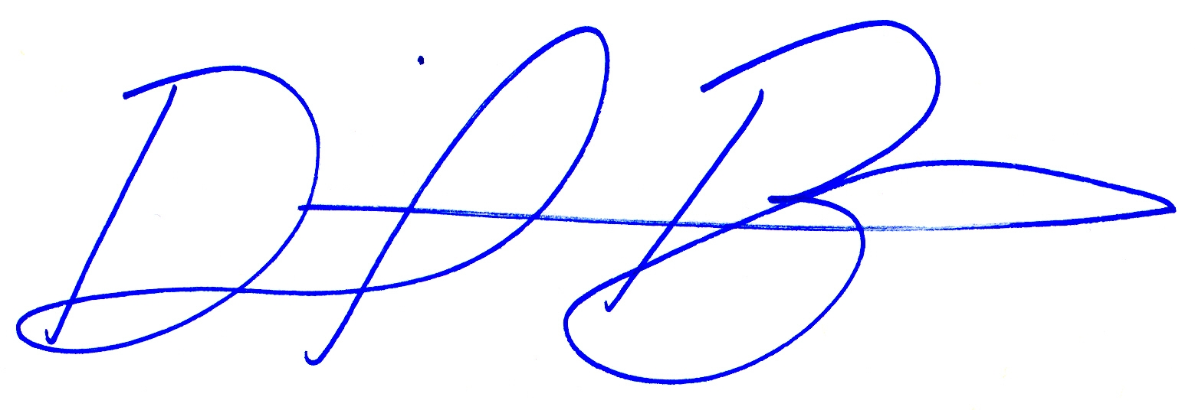

Daniel A. Barone, Chief Coastal Geomatics Specialist
Richard Stockton College Coastal Research Center

