
J. Bailey Smith July 31, 2026
Regional Technical Specialist in Coastal Plan Formulation
US Army Corps of Engineers
Philadelphia District
The Wanamaker Building
100 Penn Square East
Philadelphia, PA 19107-3390

Dear Mr. Smith:

The Richard Stockton College Coastal Research Center (CRC) has completed field work and subsequent data processing for the project entitled “Site Characterization of a Delaware River Disposal Area: Artificial Island”. The deliverables (stated in the Scope of Work) will be sent to you in late-January 2010 and will include a CD-ROM Disk containing:

- All GPS data collected for sediment sample locations (including elevations) in the form of ESRI ArcGIS shapefiles.
- All digital field photographs.
- Stratigraphic logs of core samples collected at various discharge areas (PDF format).
- Grain size analyses of all samples collected at Artificial Island (data will be attached to GPS point locations in GIS).
- 3-dimensional elevation surface in ESRI TIN format for visualization purposes.
- Sediment Volume Calculations for Artificial Island as well as areas specified areas within Artificial Island (sandy areas located around discharges).
- Sediment distributions for the entire CDF based on percent sand compositions of all collected sediment samples/cores.
- Additional ESRI ArcGIS shapefiles generated for this project including contour lines and derived point elevations, sediment type boundaries (sand/silt areas), etc.
- Google Earth KML files representing data collected and analyzed at Artificial Island (based on products described above). Google Earth is free software and the associated KML files allow for quick visualization of 3-dimensional data overlain on aerial photography.

It has been a pleasure working with the USACE and are sure you will pleased will the products generated as a result of this project. We hope that there can be a continued working relationship and that the CRC can provide future services to benefit your district.

Sincerely,
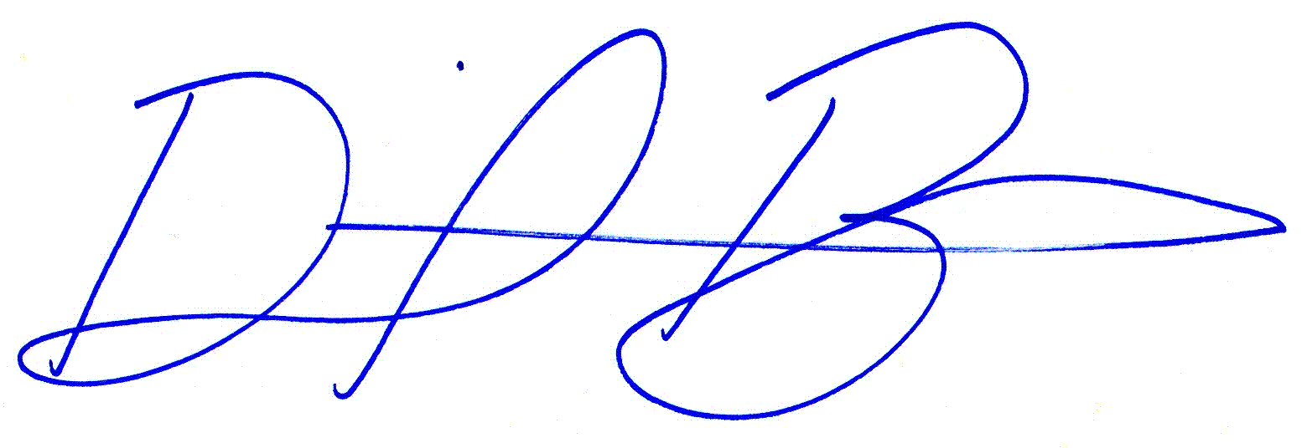
Daniel A. Barone
Chief Coastal Geomatics Specialist
Coastal Research Center

