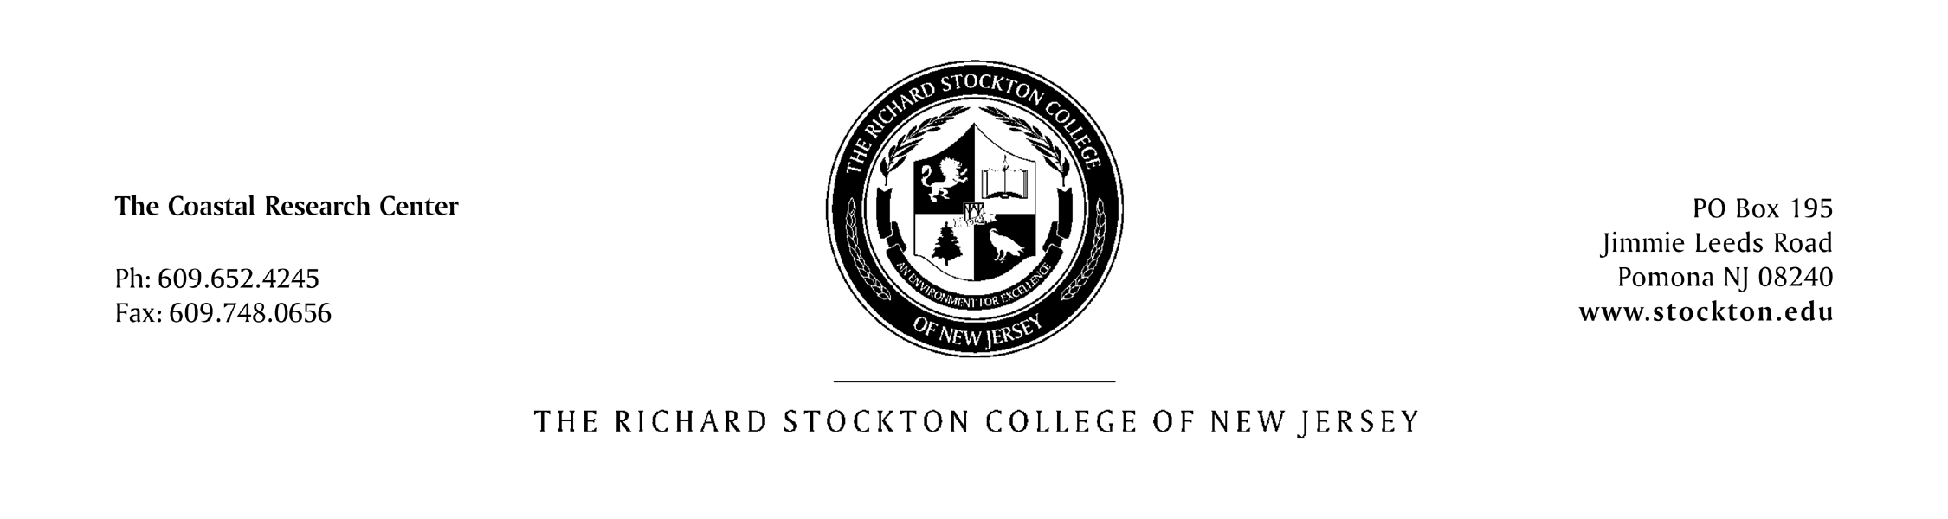
J. Bailey Smith
Regional Technical Specialist in Coastal Plan Formulation
US Army Corps of Engineers
Philadelphia District
The Wanamaker Building
100 Penn Square East
Philadelphia, PA 19107-3390
Dear Mr. Smith,

The Richard Stockton College Coastal Research Center (CRC) has comprised a proposal outlining the site characterization of the confined disposal facility (CDF) along the Delaware River known as Artificial Island in Salem, New Jersey. CDF site characterizations provide crucial data for key stakeholders working within the coastal zone such as federal, state, and local governments, marina owners, as well as local waterfront property owners.

The data that are to be collected and analyzed include sedimentological, GPS RTK elevation (topography), and site photographs. In addition to collecting data during the CDF site visits, the CRC will process all geographically referenced data to produce 3-dimensional representations of the bare CDF surface, sediment distributions of surficial materials contained within the CDF dikes, and calculate existing sediment volumes within the CDF (percent sand). Furthermore, the data collected and processed from Artificial Island will be catalogued and made available in the Dredged Material Management System (DMMS). The DMMS is an NJDOT funded project where all compiled dredged material data within the State of New Jersey will be housed and made available to the public via the world web using an online mapping interface. A key function of the DMMS is the matching of suitable dredged material with beneficial use opportunities, cost-effective placement of dredged material and efficient CDF management.

The characterization of Artificial Island CDF will be another crucial step in contributing data to a well maintained, and ever expanding dredged material database which the CRC is compiling for the online launch of the DMMS in spring 2010. Data is this nature is a key factor in proper sediment management, and the CRC is aiming to bring all key stakeholders together to properly address dredging issues and bring up-to-date data to coastal zone managers and the public alike.

The following pages propose the tasks involved with the CDF site characterization of Artificial Island in Salem, New Jersey. If you have any questions or concerns regarding this project, don’t hesitate to contact the CRC.

Regards,

Daniel A. Barone, M.A.

Richard Stockton College COASTAL RESEARCH CENTER
PROPOSAL FOR CDF SITE CHARACTERIZATION OF ARTIFICIAL ISLAND, SALEM, NEW JERSEY

TASK ONE: ARTIFICIAL ISLAND CDF FIELDWORK
Personnel Costs $ 43,896.95
Boat $ 2,325.00
Travel $ 800.00
Equipment Use $ 2,000.00
Expendable Supplies $ 750.00

TOTAL TASK ONE $ 49,771.95

TASK TWO: ARTIFICIAL ISLAND GIS ANALYSIS OF FIELD COLLECTED
DATA & GRAIN SIZE ANALYSIS
Personnel Costs $ 21,977.95
Expendable Supplies $ 100.00
Equipment Use $ 1,000.00

TOTAL TASK TWO $ 23,077.95

TASK THREE: ARTIFICIAL ISLAND ELECTRONIC REPORT
Personnel Costs $ 36,106.93
Contractor $ 8,900.00
Travel $ 160.00

TOTAL TASK FOUR $ 45,166.93

